Freeform Mixed Shapes
# Source: AI Source: Provided by: [Data Path: Persons Table -> ID Column: 1, Name_En Column: Motasem Essam] -> From: [ChatGPT] on [7/25/2026]
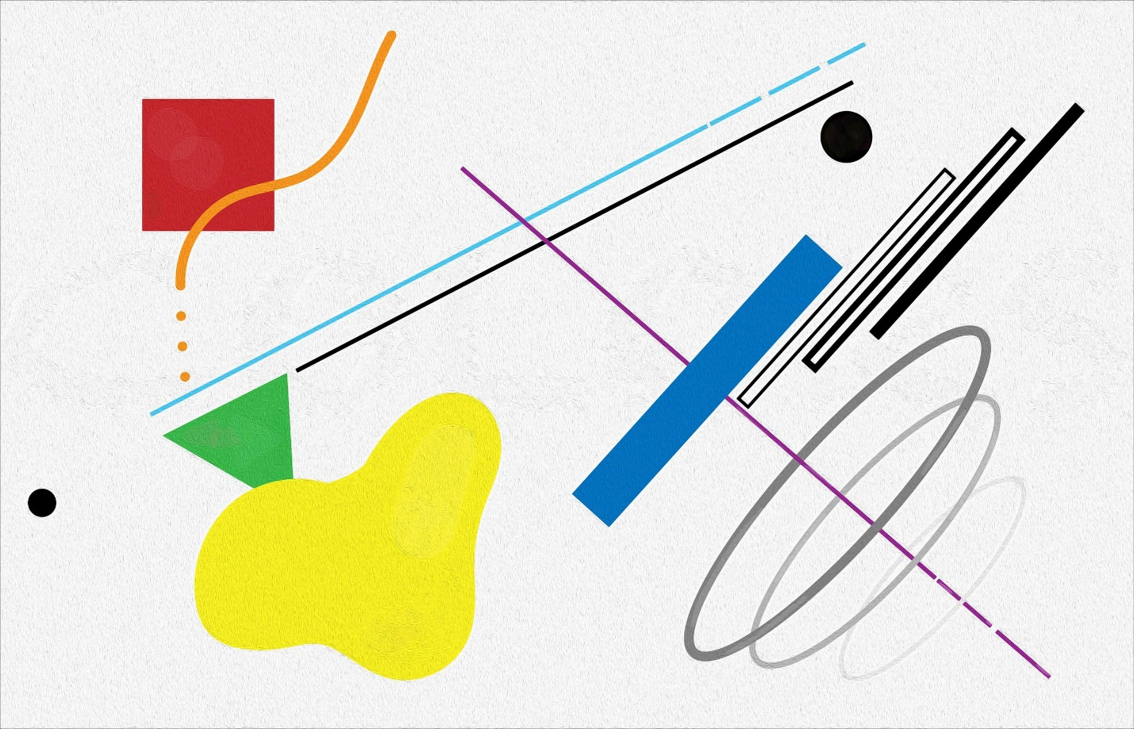
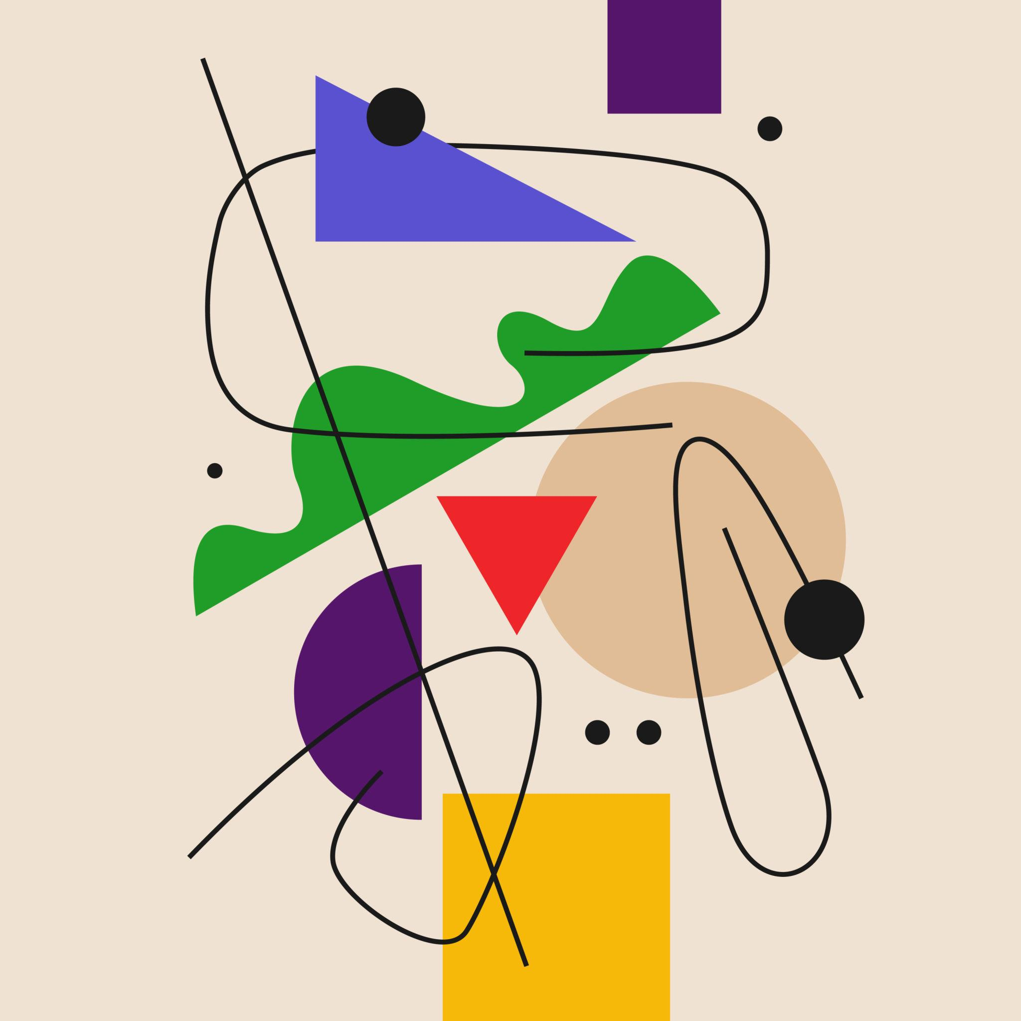
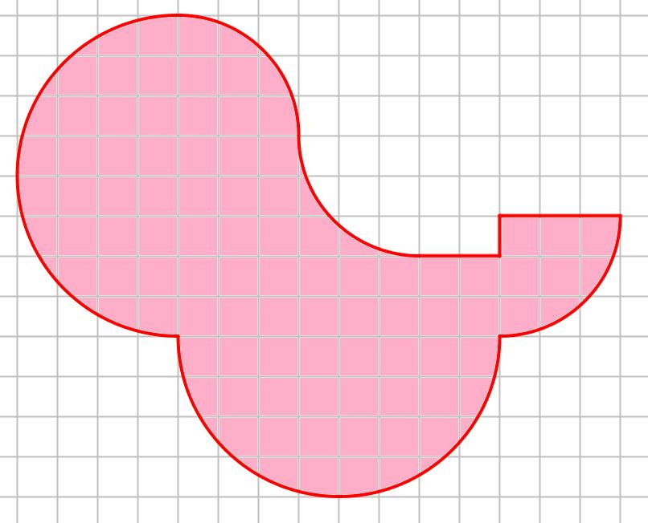
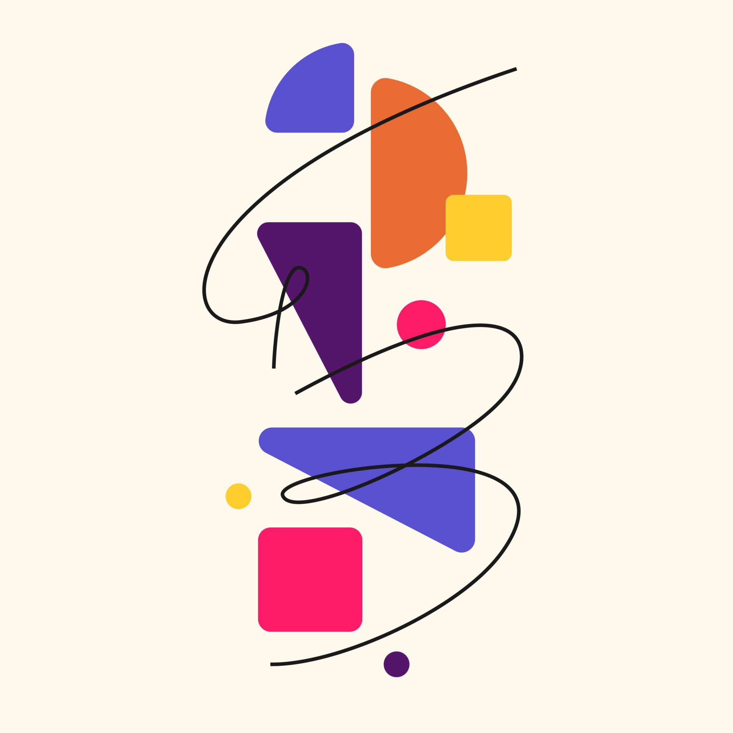
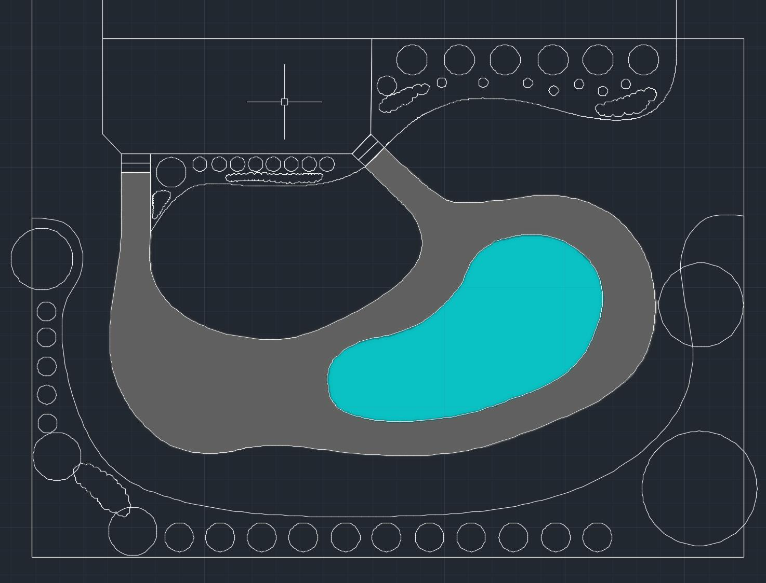
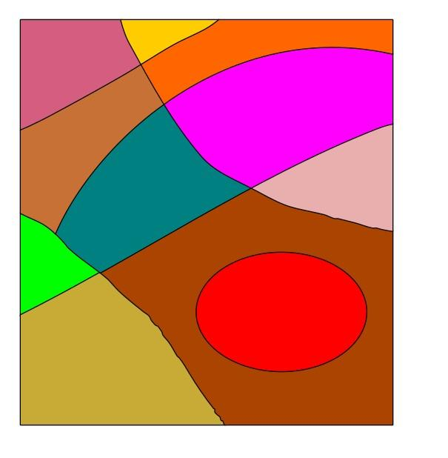

Definition
# Source: AI Source: Provided by: [Data Path: Persons Table -> ID Column: 1, Name_En Column: Motasem Essam] -> From: [ChatGPT] on [7/25/2026]
Freeform Mixed Shapes are freeform shapes whose boundaries or structures combine different types of geometric elements, especially straight-line segments and curved lines, without following a fixed standard geometric form or predetermined regular pattern.
They may combine:
- Straight-line segments
- Curved segments
- Smooth curves
- Angled segments
- Irregular proportions
- Different directions and transitions
A mixed freeform shape is therefore characterized by both freeform structure and mixed geometric elements.

Fundamental Concept
# Source: AI Source: Provided by: [Data Path: Persons Table -> ID Column: 1, Name_En Column: Motasem Essam] -> From: [ChatGPT] on [7/25/2026]
The defining idea is:
A Freeform Mixed Shape combines different boundary or structural elements while maintaining a non-standard, flexible form.
For example, a shape may have:
- A straight top edge
- A curved side
- An angled corner
- Another curved section
Such a shape does not belong entirely to a purely straight-line or purely curved category.
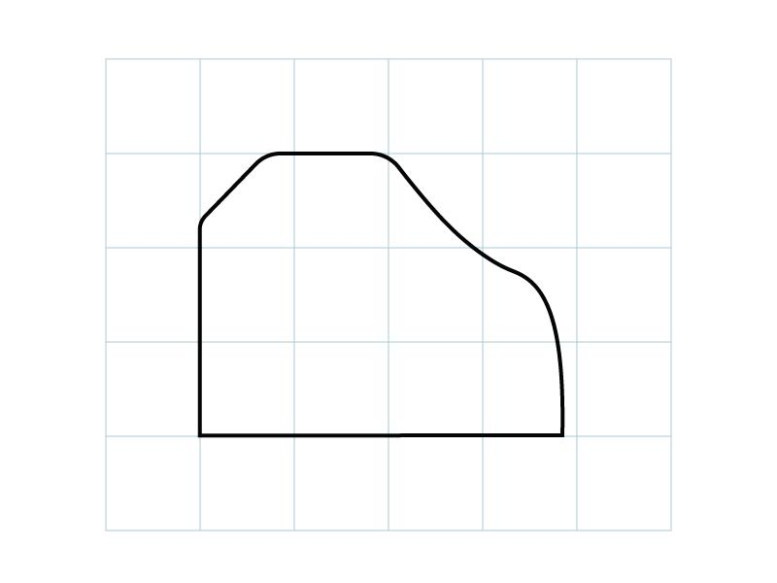
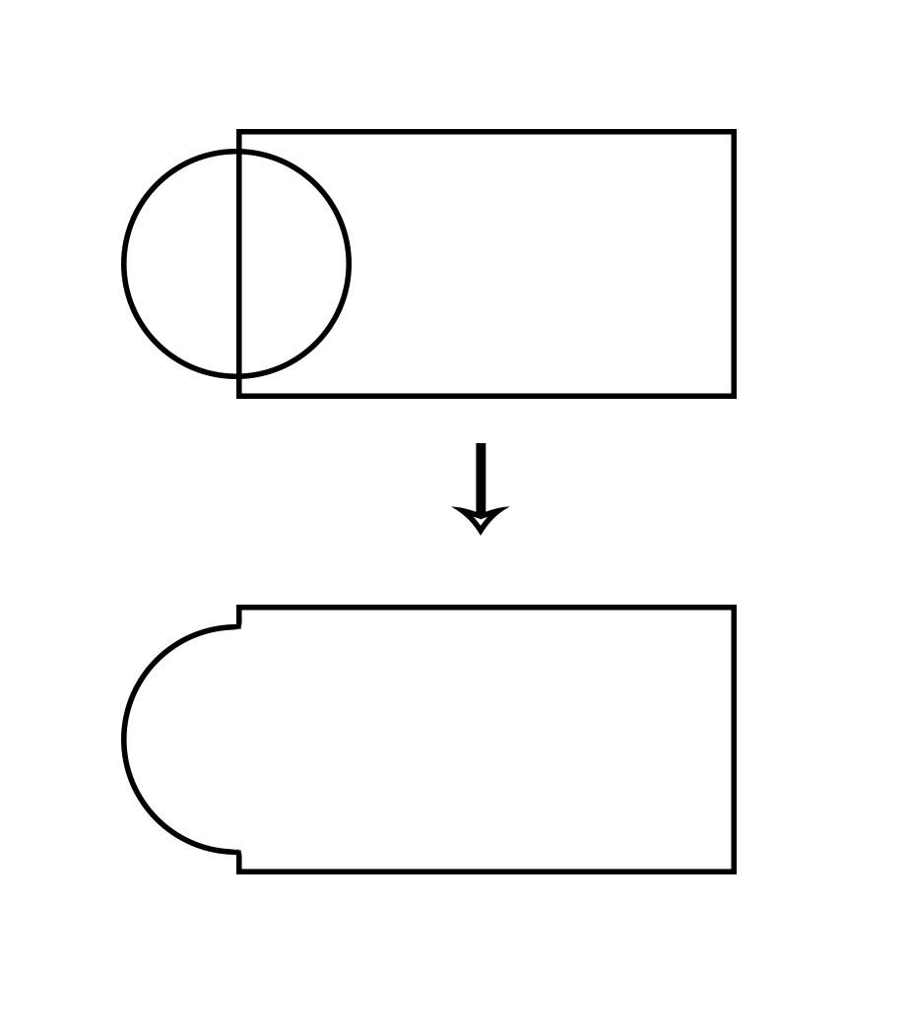
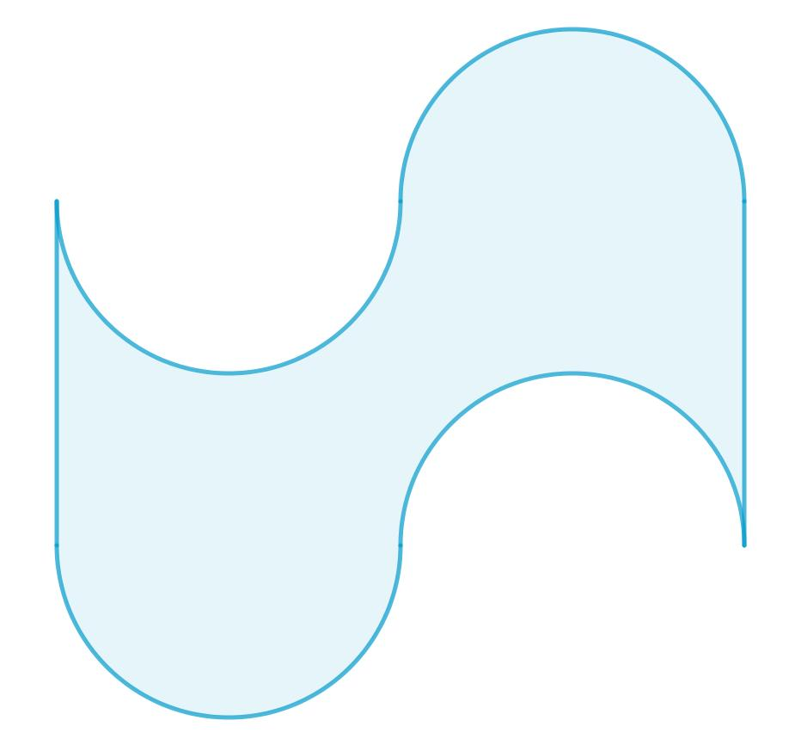
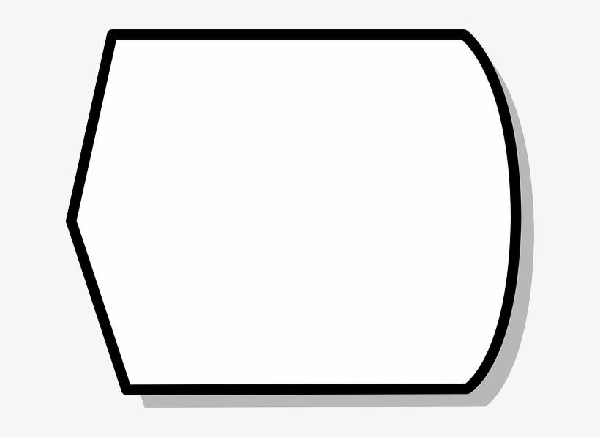

Main Characteristics
# Source: AI Source: Provided by: [Data Path: Persons Table -> ID Column: 1, Name_En Column: Motasem Essam] -> From: [ChatGPT] on [7/25/2026]
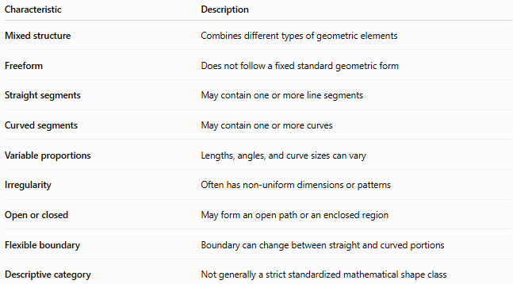
Characteristic | Description
Mixed structure | Combines different types of geometric elements
Freeform | Does not follow a fixed standard geometric form
Straight segments | May contain one or more line segments
Curved segments | May contain one or more curves
Variable proportions | Lengths, angles, and curve sizes can vary
Irregularity | Often has non-uniform dimensions or patterns
Open or closed | May form an open path or an enclosed region
Flexible boundary | Boundary can change between straight and curved portions
Descriptive category | Not generally a strict standardized mathematical shape class

Basic Structure
# Source: AI Source: Provided by: [Data Path: Persons Table -> ID Column: 1, Name_En Column: Motasem Essam] -> From: [ChatGPT] on [7/25/2026]
A Freeform Mixed Shape can be represented as a combination of different boundary elements:
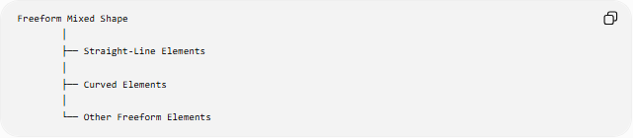
Freeform Mixed Shape
│
├── Straight-Line Elements
│
├── Curved Elements
│
└── Other Freeform Elements
For a closed mixed shape:
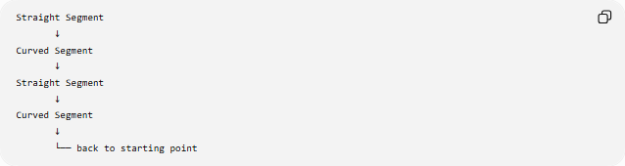
Straight Segment
↓
Curved Segment
↓
Straight Segment
↓
Curved Segment
↓
└── back to starting point
The transition between two elements may be:
- Sharp — a corner or directional change
- Smooth — the curve joins the line continuously
- Irregular — the transition does not follow a simple standard pattern

Types of Freeform Mixed Shapes
# Source: AI Source: Provided by: [Data Path: Persons Table -> ID Column: 1, Name_En Column: Motasem Essam] -> From: [ChatGPT] on [7/25/2026]
A useful descriptive classification is:
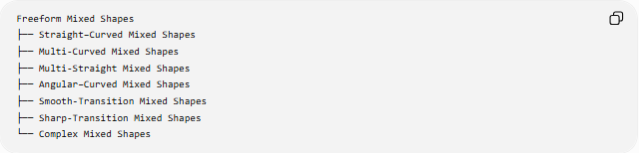
Freeform Mixed Shapes
├── Straight–Curved Mixed Shapes
├── Multi-Curved Mixed Shapes
├── Multi-Straight Mixed Shapes
├── Angular–Curved Mixed Shapes
├── Smooth-Transition Mixed Shapes
├── Sharp-Transition Mixed Shapes
└── Complex Mixed Shapes

1-Straight–Curved Mixed Shapes
# Source: AI Source: Provided by: [Data Path: Persons Table -> ID Column: 1, Name_En Column: Motasem Essam] -> From: [ChatGPT] on [7/25/2026]
Shapes that combine straight-line segments and curved segments.
Example:
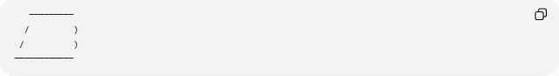
─────────
/ )
/ )
────────────
These are among the most common freeform mixed shapes.

2-Multi-Curved Mixed Shapes
# Source: AI Source: Provided by: [Data Path: Persons Table -> ID Column: 1, Name_En Column: Motasem Essam] -> From: [ChatGPT] on [7/25/2026]
Shapes containing multiple different curved sections, potentially combined with other elements.
The curves may differ in:
- Radius
- Curvature
- Direction
- Length
- Smoothness
They do not necessarily follow the same mathematical curve.

3-Multi-Straight Mixed Shapes
# Source: AI Source: Provided by: [Data Path: Persons Table -> ID Column: 1, Name_En Column: Motasem Essam] -> From: [ChatGPT] on [7/25/2026]
Shapes primarily composed of several straight-line segments with different:
- Directions
- Lengths
- Angles
- Orientations
They remain freeform when they do not conform to a fixed standard polygonal pattern.

4-Angular–Curved Mixed Shapes
# Source: AI Source: Provided by: [Data Path: Persons Table -> ID Column: 1, Name_En Column: Motasem Essam] -> From: [ChatGPT] on [7/25/2026]
Shapes that combine:
- Angular corners
- Straight edges
- Curved sections
For example, a boundary might transition from a straight horizontal segment into a curved side and then into another angled segment.

5-Smooth-Transition Mixed Shapes
# Source: AI Source: Provided by: [Data Path: Persons Table -> ID Column: 1, Name_En Column: Motasem Essam] -> From: [ChatGPT] on [7/25/2026]
Shapes in which straight and curved portions are joined smoothly.
At a smooth transition, the direction of the boundary does not change abruptly.
This is common in:
- Industrial design
- Product design
- Automotive forms
- CAD models
- Graphic design

6-Sharp-Transition Mixed Shapes
# Source: AI Source: Provided by: [Data Path: Persons Table -> ID Column: 1, Name_En Column: Motasem Essam] -> From: [ChatGPT] on [7/25/2026]
Shapes in which different boundary elements meet at distinct corners or sharp changes in direction.
For example:
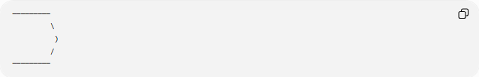
─────────
\
)
/
─────────
The straight and curved sections are clearly distinguishable.

7-Complex Mixed Shapes
# Source: AI Source: Provided by: [Data Path: Persons Table -> ID Column: 1, Name_En Column: Motasem Essam] -> From: [ChatGPT] on [7/25/2026]
Shapes that combine several different elements or multiple freeform components.
They may contain:
- Several straight sections
- Several curves
- Different transition types
- Multiple indentations
- Multiple components
- Self-intersections in some designs
Complex here is descriptive rather than a universal mathematical classification.

Open and Closed Freeform Mixed Shapes
# Source: AI Source: Provided by: [Data Path: Persons Table -> ID Column: 1, Name_En Column: Motasem Essam] -> From: [ChatGPT] on [7/25/2026]
Freeform Mixed Shapes can also be classified according to whether their boundaries are open or closed.

Open Freeform Mixed Shape
# Source: AI Source: Provided by: [Data Path: Persons Table -> ID Column: 1, Name_En Column: Motasem Essam] -> From: [ChatGPT] on [7/25/2026]
An open mixed shape has two endpoints and does not completely enclose a region.
Straight → Curve → Straight → Curve
●──────────────────────────────●
If represented as a sequence of points and curves, it can be modeled parametrically as:
$$r\left(t\right)=\left(x , \left(t\right)y\left(t\right)\right)$$
with different portions of the parameter interval representing different boundary elements.

Closed Freeform Mixed Shape
# Source: AI Source: Provided by: [Data Path: Persons Table -> ID Column: 1, Name_En Column: Motasem Essam] -> From: [ChatGPT] on [7/25/2026]
A closed mixed shape returns to its starting point and encloses a region.
$$r\left(a\right)=r\left(b\right)$$
A closed mixed shape may contain both:
- Straight boundary segments
- Curved boundary segments
Its area can be calculated using appropriate methods depending on the geometry.
For a sufficiently smooth closed parametric boundary:
$$A=\frac{1}{2}\oint{(}\left.x dy-y dx\right)$$

Mathematical Representation
# Source: AI Source: Provided by: [Data Path: Persons Table -> ID Column: 1, Name_En Column: Motasem Essam] -> From: [ChatGPT] on [7/25/2026]
A Freeform Mixed Shape can be represented piecewise.
For example:
$$r\left(t\right)=\left\{\begin{matrix}r_{1}\left(t\right), & a≤t<c \\ r_{2}\left(t\right), & c≤t<d \\ r_{3}\left(t\right), & d≤t≤e\end{matrix}\right.$$
where the individual portions may represent different geometric elements.
For example:
- $r_{1}\left(t\right)$→ straight line
- $r_{2}\left(t\right)$→ curved section
- $r_{3}\left(t\right)$→ another straight or curved section
Straight segment
A line segment between points $P_{1}$and $P_{2}$can be written as:
$$r\left(t\right)=\left(1-t\right)P_{1}+tP_{2}$$
where:
$$0≤t≤1$$
Curved segment
A curved section can be represented by a suitable function or parametric curve.
Thus, a mixed shape can combine several mathematical representations.

Continuity at Transitions
# Source: AI Source: Provided by: [Data Path: Persons Table -> ID Column: 1, Name_En Column: Motasem Essam] -> From: [ChatGPT] on [7/25/2026]
When a straight segment meets a curved segment, the transition may be continuous.
Position continuity
The two portions meet at the same point:
$$r_{1}\left(c\right)=r_{2}\left(c\right)$$
Tangent continuity
If the direction also matches at the transition:
$$r_{1}^{'}\left(c\right)=r_{2}^{'}\left(c\right)$$
This produces a smooth transition.
If the tangent directions differ, the boundary has a corner or sharp transition.

Area and Perimeter
# Source: AI Source: Provided by: [Data Path: Persons Table -> ID Column: 1, Name_En Column: Motasem Essam] -> From: [ChatGPT] on [7/25/2026]
For a closed Freeform Mixed Shape, its perimeter consists of the lengths of all straight and curved portions.
$$P=L_{\text{straight}}+L_{\text{curved}}$$
More generally:
$$P=\sum{L_{i}}$$
where each $L_{i}$is the length of an individual boundary component.
For a straight segment:
$$L=\sqrt{{\left(x_{2}-x_{1}\right)}^{2}+{\left(y_{2}-y_{1}\right)}^{2}}$$
For a smooth curve:
$$L=\int_{a}^{b}{\sqrt{{\left(\frac{dx}{dt}\right)}^{2}+{\left(\frac{dy}{dt}\right)}^{2}}} dt$$
The area depends on the particular combination of straight and curved boundaries.

Examples

Example 1 — Straight and Curved Boundary
# Source: AI Source: Provided by: [Data Path: Persons Table -> ID Column: 1, Name_En Column: Motasem Essam] -> From: [ChatGPT] on [7/25/2026]
A shape with:
- Two straight edges
- One curved edge
- One irregular transition
is a Freeform Mixed Shape.

Example 2 — Product-Like Form
# Source: AI Source: Provided by: [Data Path: Persons Table -> ID Column: 1, Name_En Column: Motasem Essam] -> From: [ChatGPT] on [7/25/2026]
A shape can have:
- A flat bottom
- Rounded sides
- An angled upper section
- A curved top
This is a mixed freeform structure.

Example 3 — Abstract Mixed Shape
# Source: AI Source: Provided by: [Data Path: Persons Table -> ID Column: 1, Name_En Column: Motasem Essam] -> From: [ChatGPT] on [7/25/2026]
An abstract closed shape can combine several:
- Straight segments
- Circular arcs
- Freeform curves
without matching a standard polygon or conic.

Freeform Mixed Shapes vs Other Shape Types
# Source: AI Source: Provided by: [Data Path: Persons Table -> ID Column: 1, Name_En Column: Motasem Essam] -> From: [ChatGPT] on [7/25/2026]
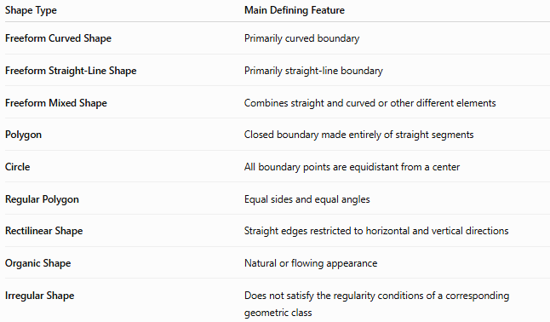
Shape Type | Main Defining Feature
Freeform Curved Shape | Primarily curved boundary
Freeform Straight-Line Shape | Primarily straight-line boundary
Freeform Mixed Shape | Combines straight and curved or other different elements
Polygon | Closed boundary made entirely of straight segments
Circle | All boundary points are equidistant from a center
Regular Polygon | Equal sides and equal angles
Rectilinear Shape | Straight edges restricted to horizontal and vertical directions
Organic Shape | Natural or flowing appearance
Irregular Shape | Does not satisfy the regularity conditions of a corresponding geometric class
Important distinction
A Freeform Mixed Shape is not simply the same thing as an irregular shape.
For example, an irregular pentagon is still entirely a polygon. It does not become a mixed shape merely because its sides have different lengths.

Freeform Mixed Shapes and Symmetry
# Source: AI Source: Provided by: [Data Path: Persons Table -> ID Column: 1, Name_En Column: Motasem Essam] -> From: [ChatGPT] on [7/25/2026]
A Freeform Mixed Shape can be:
- Symmetric
- Asymmetric
- Partially symmetric
For reflection symmetry:
$$R\left(S\right)=S$$
where $R$represents the relevant reflection.
The presence of both straight and curved elements does not prevent a shape from being symmetric.

Freeform Mixed Shapes and Open/Closed Structure
# Source: AI Source: Provided by: [Data Path: Persons Table -> ID Column: 1, Name_En Column: Motasem Essam] -> From: [ChatGPT] on [7/25/2026]
The classifications can overlap.
For example:
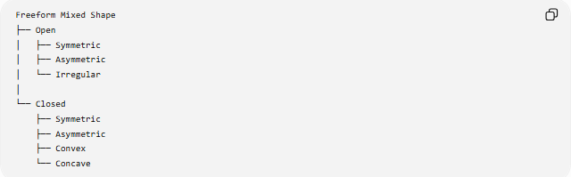
Freeform Mixed Shape
├── Open
│ ├── Symmetric
│ ├── Asymmetric
│ └── Irregular
│
└── Closed
├── Symmetric
├── Asymmetric
├── Convex
└── Concave
These are different properties rather than mutually exclusive categories.
A shape can therefore be:
Closed + Mixed + Freeform + Symmetric
or:
Closed + Mixed + Freeform + Asymmetric

Classification Summary
# Source: AI Source: Provided by: [Data Path: Persons Table -> ID Column: 1, Name_En Column: Motasem Essam] -> From: [ChatGPT] on [7/25/2026]
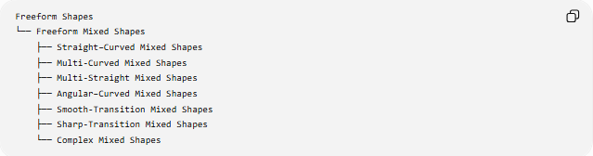
Freeform Shapes
└── Freeform Mixed Shapes
├── Straight–Curved Mixed Shapes
├── Multi-Curved Mixed Shapes
├── Multi-Straight Mixed Shapes
├── Angular–Curved Mixed Shapes
├── Smooth-Transition Mixed Shapes
├── Sharp-Transition Mixed Shapes
└── Complex Mixed Shapes
A broader structural classification is:
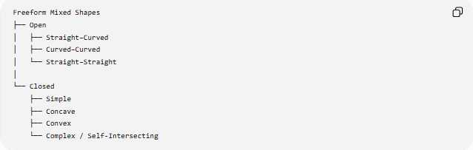
Freeform Mixed Shapes
├── Open
│ ├── Straight–Curved
│ ├── Curved–Curved
│ └── Straight–Straight
│
└── Closed
├── Simple
├── Concave
├── Convex
└── Complex / Self-Intersecting
The second classification describes structural properties, while the first describes the types of elements being mixed.

Key Points
# Source: AI Source: Provided by: [Data Path: Persons Table -> ID Column: 1, Name_En Column: Motasem Essam] -> From: [ChatGPT] on [7/25/2026]
- Freeform Mixed Shapes combine different types of geometric elements.
- The most common combination is straight segments + curved segments.
- They do not follow a fixed standard geometric form.
- They can be open or closed.
- Closed mixed shapes can enclose an area.
- Transitions between elements may be smooth or sharp.
- They can be symmetric or asymmetric.
- They may be simple, concave, convex, or complex, depending on their structure.
- “Freeform Mixed Shape” is primarily a descriptive classification, rather than a universally standardized mathematical category.
- Mixed describes the combination of elements, while freeform describes the absence of a fixed standard form.

Conclusion
# Source: AI Source: Provided by: [Data Path: Persons Table -> ID Column: 1, Name_En Column: Motasem Essam] -> From: [ChatGPT] on [7/25/2026]
A Freeform Mixed Shape is a flexible shape that combines different geometric elements—most commonly straight-line segments and curved sections—without conforming to a predetermined standard geometric form. Its classification can be further refined according to whether it is open or closed, simple or complex, symmetric or asymmetric, and whether its transitions are smooth or sharp.

